ACCA has 8355 Member Firms:

7199 advertise their Certificates on the website. Certificates are a range of formal attributes and capabilities for the firm, and take a standard form:

6899 are “wholly composed of Chartered Certified Accountants”,

1893 are “registered as auditors in the UK/Ireland by ACCA”,

792 are “regulated to undertake a range of investment business activities by ACCA under the Financial Services and Markets Act 2000”, and

406 are “regulated to undertake a range of credit related activities under the Financial Services and Markets Act 2000”

3652 advertise a particular set of services, and 3094 claim expertise in a one or more specific sectors – these are detailed on the following slide.

Of the 8355 Members:

All provide a valid address and postcode

8219 provide a telephone number

7601 provide an email address

3946 provide a website

Email address and telephone number are particularly valuable for matching purposes, which should improve the mate rate that we achieve. The main issue will be the accuracy and completeness of our data in this case.

The nearly 4k websites could provide a basis for a web robots project to identify agent business models based on their websites – we have never had a valid list of agent websites for this work before, so this represents an important step up in capability

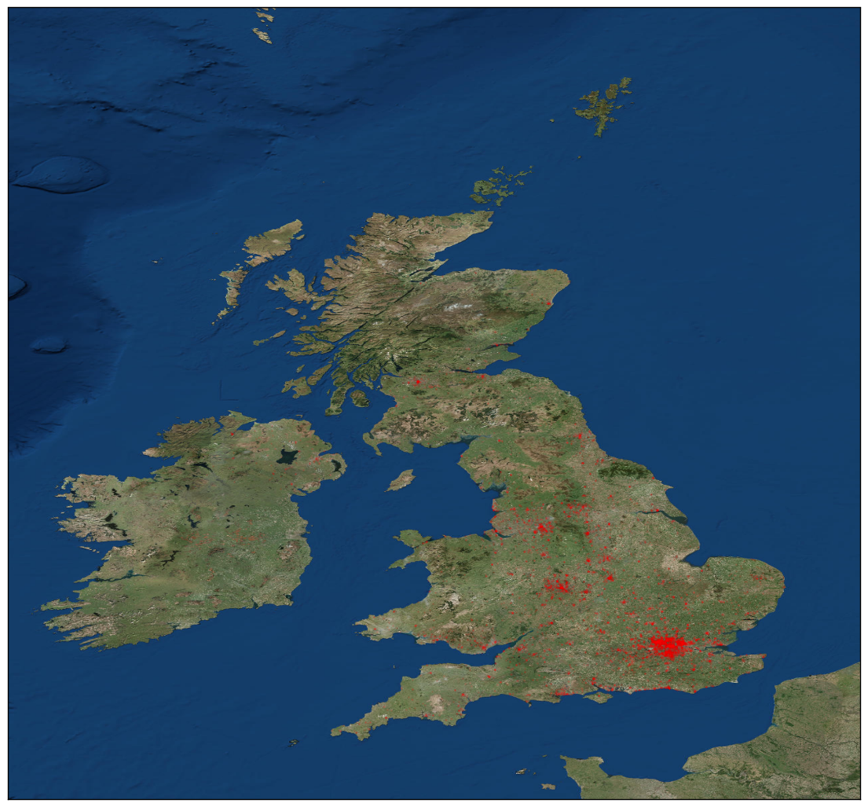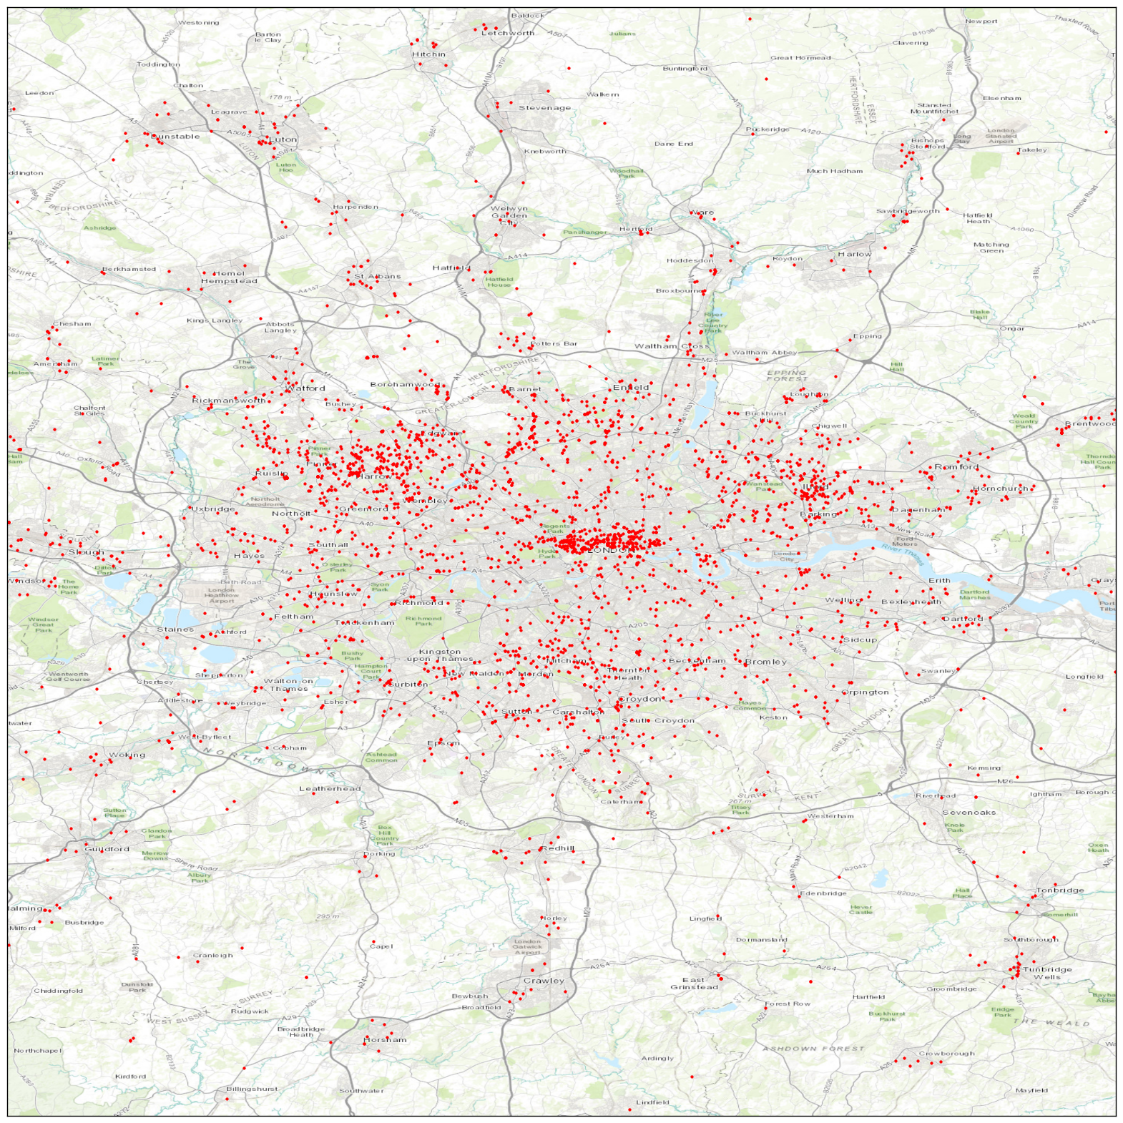

|  |  |
| --- | --- |
| **Number** | **Sector or Service Expertise** |
| 3103 | Partnership / sole trader accounts |
| 3023 | Limited company accounts |
| 2969 | Tax(CGT, Corporate, IHT, Personal and VAT) |
| 2482 | Business start-up and company formation |
| 2154 | Management accounting consultancy |
| 2071 | Business plans |
| 1994 | Retail |
| 1972 | Management advice to business |
| 1840 | Tax and NI investigations |
| 1830 | Sub-Contractors |
| 1744 | Company secretarial service |
| 1685 | Construction Industry |
| 1638 | Catering (Pubs, Restaurants, Food and Drink) |
| 1532 | Management consultancy |
| 1499 | IT/Software |
| 1407 | Manufacturing |
| 1251 | Service Industries |
| 1105 | Motor Retailers |
| 1064 | Charities |
| 1051 | Printing and Publishing |
| 1018 | Engineering |
| 978 | Dentists |
| 951 | Clubs and Associations |
| 932 | Distribution and Transport |
| 910 | Information Technology |
| 910 | Estate Agents |
| 905 | Doctors |
| 860 | Solicitors |
| 805 | Entertainment |
| 751 | Tourism and Travel Agents |
| 737 | Cost systems and control |
| 672 | Advertising |
| 667 | Housing |
| 659 | Data processing services |
| 629 | Business process improvements |
| 595 | Architects |
| 551 | Financial Services |
| 536 | Share valuations |
| 447 | Education |
| 433 | Internal audit and systems security |
| 424 | Bank loans and overdrafts (inc SFLGS) |
| 382 | Telecommunications |
| 372 | Arts and Cultures Industries |
| 343 | Trusteeship / Trust Administration |
| 338 | Corporate finance |
| 330 | Vets |
| 329 | Estate planning and executorship |
| 325 | Feasibility studies |
| 299 | Agriculture and Forestry |
| 296 | Small scale equity issues |
| 268 | Friendly Societies |
| 266 | Grants and Finance (EU,government) |
| 253 | Business risk assessment |
| 221 | Benchmarking |
| 207 | Debt counselling |
| 196 | Public sector |
| 177 | Establishing a business overseas |
| 173 | Expert witness |
| 162 | Corporate recovery |
| 142 | Divorce matrimonial |
| 123 | Export finance planning and tax |
| 120 | Business plans (external and internal) |
| 117 | Treasury |
| 116 | Start-up Finance(inc using own funds) |
| 50 | Available for Continuity of Practice |
| 31 | Arbitration |
| 18 | Environmental auditing |